
SRM Institute of Science and Technology
Mode of Exam
OFFLINE
College of Engineering and Technology
School of Computing
DEPARTMENT OF COMPUTING TECHNOLOGIES
SRM Nagar, Kattankulathur – 603203, Chengalpattu District, Tamilnadu
Academic Year: 2022 - 2023 - Odd Semester
Test: CLAT-3 SET C Date: 02.11.2023
Course Code & Title: 18CSE453T& NETWORK ROUTING ALGORITHMS Duration: 8AM -9.40AM
Year & Sem: III /IV & V / VII Sem Max. Marks: 50

Course Articulation Matrix:
S.No. | Course Outcome | PO1 | PO2 | PO3 | PO4 | PO5 | PO6 | PO7 | PO8 | PO9 | PO10 | PO11 | PO12
1 | CO1 | H |  | M |  |  |  |  |  |  |  |  | M
2 | CO2 |  | M | L |  | H
3 | CO3 |  | H | L | H
4 | CO4 | M | H | H
5 | CO5 |  | H |  | H | H
6 | CO6. |  | H |  | H | H

Part - A
(10 * 1 = 10 Marks)
Instructions: Answer all the Questions
Q. No | Question | Marks | BL | CO | PO | PI Code
1 | Which of the following does not belong to a type of OSPF packet?  - Hello packet  - Link state update  - Link state response  - Link state request | 1 | 1 | 4 | 1 | 1.4.1
2 | What is the correct order of the operations of OSPF?  i – Hello packets  ii – Propagation of link-state information and building of routing tables  iii – Establishing adjacencies and synchronization of database  - i-ii-iii  - i-iii-ii  - iii-ii-i  - ii-i-iii | 1 | 1 | 4 | 1 | 1.4.1
3 | RIP end the routing updates to adjacent routers after every _______ seconds.  - 10  - 20  - 30  d ) 5 | 1 | 1 | 4 | 1 | 1.4.1
4 | On How many seconds does distance vector protocol sends periodic updates on the network?  a) every 15 – 30 seconds  b) every 30 – 60 seconds  c) every 30 – 90 seconds  d) every 1 minute | 1 | 2 | 4 | 2 | 2.4.1
5 | What is the cost of shortest path from R1->R3->R4 to the destination IP Address 10.10.0.0/16 from the following network?  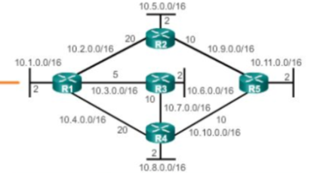  a. 15  b. 17  c. 25  d. 27 | 1 | 3 | 4 | 3 | 3.7.1
6 | Which one of the following statements is true that could identify with pure flooding?  a. every node transmits the request only once  b. every node broadcast the request only once  c. every node forwards the request multiple times  d. every node broadcasts the request multiple times | 1 | 1 | 5 | 1 | 1.4.1
7 | Specify the ranges on relatively small network diameter with respect to Dynamic Source Routing (DSR).  a. 2 – 5 hops  b. 5 – 10 hops  c. 15 – 20 hops  d. 20 – 25 hops | 1 | 2 | 5 | 1 | 1.4.1
8 | Identify the feature that makes routing complex in Adhoc wireless networks?  - Absence of central coordinator  - Absence of router  - Absence of gateway  - Absence of switches | 1 | 2 | 5 | 1 | 1.4.1
9 | In MPLS Network, At the LAST Edge LSR, label is removed from the packet. This process is called ....  - Pop  - Push  - Swap  - PHP | 1 | 2 | 5 | 1 | 1.4.1
10 | What will happen, when a neighbor node perceives a link break at a particular node?  a. it sets all routes through broken link to ∞  b. it sets all routes through broken link to 0  c. it sets all routes through broken link to 1  d. it sets all routes through broken link to negative value | 1 | 2 | 5 | 1 | 1.4.1

Part - B
(4* 10 = 40 Marks)
Instructions: Answer the Questions
Q. No | Question | Marks | BL | CO | PO | PI Code
11.a | List the advantages of RIPv2 over RIPv1. Explain the Features of RIPv2 in details with necessary diagram  RIPv1  RIPv1 stands for Routing Information Protocol version 1. It uses Classful routing. The regular routing updates do not carry subnet details and do not support Variable Length subnet masks (VLSM). This is the drawback of RIPv1, due to which it is not possible to have various sized subnets in the same network class.  In addition, all the subnets in the same network must have the same size. Also, there is no reinforcement for router identification, making RIP unprotected from numerous attacks.  RIPv2  RIPv2 stands for hybrid routing protocol version 2. It is a distance-vector routing protocol defined in RFC 1723 and has the characteristics of link-state routing protocols. It is a classless routing protocol which means it involves the subnet mask having the network addresses in the routing updates.  Due to the shortage of RIPv1, RIP version 2 (RIPv2) was introduced in 1993. It was furnished with the ability to help the subnet information and keep up with Classless inter-domain Routing (CIDR) | 10 | 2 | 4 | 1 | 1.4.1
 | (OR)
11.b | Compare and contrast different types of Distance vector routing protocols.  Examples of distance-vector routing protocols:  - Routing Information Protocol (RIP)  - Routing Information Protocol Version 2 (RIPv2)  - Routing Information Protocol Next Generation (RIPng), an extension of RIP version 2 with support for IPv6.  - Interior Gateway Routing Protocol (IGRP)  Distance vector protocols send their entire routing table to directly connected neighbors. Link state protocols send information about directly connected links to all the routers in the network. Distance vector protocols have slow convergence and suffer from the count-to-infinity problem. | 10 | 2 | 4 | 1 | 1.4.1
12.a | With necessary diagram explain the Interior Gateway Routing Protocol  An EIGRP-based router keeps a copy of its neighbor's routing tables. If it can't find a route to a destination in one of these tables, it queries its neighbors for a route, and they, in turn, query their neighbors until a route is found. When a routing table entry changes in one of the routers, it notifies its neighbors of the change only. Some earlier protocols required sending the entire table.  To keep routers aware of the state of their neighbors, each router sends out periodic HELLO packets. A router from which no HELLO packet has been received in a certain period of time is assumed to be inoperative.  To pass messages and facilitate session management, EIGRP uses five package types:  - HELLO packets. Sent out at regular intervals to facilitate the neighbor discovery process.  - QUERY packets. Used by a router to advertise that a route is in an active state and to request alternate path information from neighbors.  - REPLY packets. Sent after an entire QUERY packet has been received to acknowledge that packet's receipt.  - REQUEST packets. Used to request specific information from one or more neighbors, similar to QUERY packets but sent unreliably -- no notification if delivery fails.  - UPDATE packets. Convey information about destinations and their reachability. | 10 | 1 | 4 | 1 | 1.4.1
 | (OR)
12.b | Describe an Architectural Framework Traffic Engineering  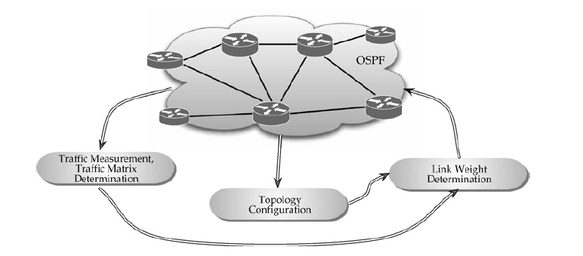  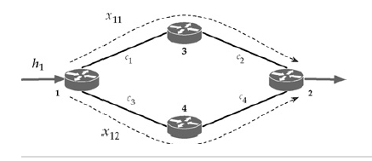 | 10 | 1 | 4 | 1 | 1.4.1
13.a | Explain about Table Driven Routing Protocol and any one of the Protocol comes under this.  Define Table Driven Routing Protocol and explain any one of the Protocol comes under this category  Destination sequenced distance vector routing protocol (DSDV)  Modification of the Bellman-Ford algorithm where each node maintains:  - the shortest path to destination;  - the first node on this shortest path.  This protocol is characterized by the following:  - routes to destination are readily available at each node in the routing table (RT);  - RTs are exchanged between neighbors at regular intervals;  - RTs are also exchanged when significant changes in local topology are observed by a node.  RT updates can be of two types:  - incremental updates:  - take place when a node does not observe significant changes in a local topology;  - full dumps:  take place when significant changes of local topology are observed; | 10 | 2 | 5 | 2 | 2.1.2
 | (OR)
13.b | Explain Link-Based Routing Protocols With Efficient Flooding Mechanisms in detail  OLSR stands for Optimized Link State Routing Protocol. In this, each node periodically floods status of its links. Each node re-broadcasts link state information received from its neighbors. Each node keeps track of link state information received from other nodes. Each node uses above information to determine next hope to each destination. It is proactive and table-driven.  Link State Routing :  Each node expands a spanning tree.  Each node can obtain the whole network topology.  It utilizes a technique to reduce message flooding – MultiPoint Relaying (MPR). In this, each node N in the network selects a set of neighbor nodes as multipoint relays, MPR(N), that retransmit control packets from N- Neighbors not in MPR(N) process control packets from N, but they do not forward the packets. MPR(N) is selected such that all two-hops neighbors of N are covered by (one-hop neighbors) of MPR(N).  Advantages of OLSR:  - OLSR has less average end-to-end delay therefore it is used for applications that needs minimum delay.  - The OLSR implementation is more user-friendly and worked with fewer headaches than other protocols.  - It is also a flat routing protocol.  - It does not need a central administrative system to handle its routing process.  - It increases the protocol’s suitability for an ad hoc network with the rapid changes of the source and destination pairs.  Disadvantages of OLSR :  - It maintains routing table for all the possible routes.  - When the number of mobile hosts increases, then the overhead from the control messages also increases.  - It needs considerable time to re-discover a broken link.  - It requires more processing power than other protocols when discovering an alternate route. | 10 | 2 | 5 | 2 | 2.1.2
14.a | With necessary graph on nodes, describe the following with respect to Ad Hoc On-demand Distance Vector (AODV)  a. AODV Route Discovery  b. Route Reply  c. Route Expiry  d. Route Optimization  The AODV protocol performs as follows:  - when a node does not have a valid route to destination a RouteRequest is forwarded;  - when intermediate node receives a RouteRequest packet two cases are possible:  - if it does not have a valid route to destination, the node forwards it;  - if it has a valid route, the node prepares a RouteReply message:  - if the RouteRequest is received multiple times, the duplicate copies are discarded:  - are determined comparing BcastID-SrcID pairs.  - when RouteRequest is forwarded, the address of previous node and its BcastID are stored;  - are needed to forward packets to the source.  - if RouteReply is not received before a time expires, this entry is deleted;  - either destination node or intermediate node responses with valid route;  - when RouteRequest is forwarded back, the address of previous node and its BcastID are stored;  - are needed to forward packets to the destination.  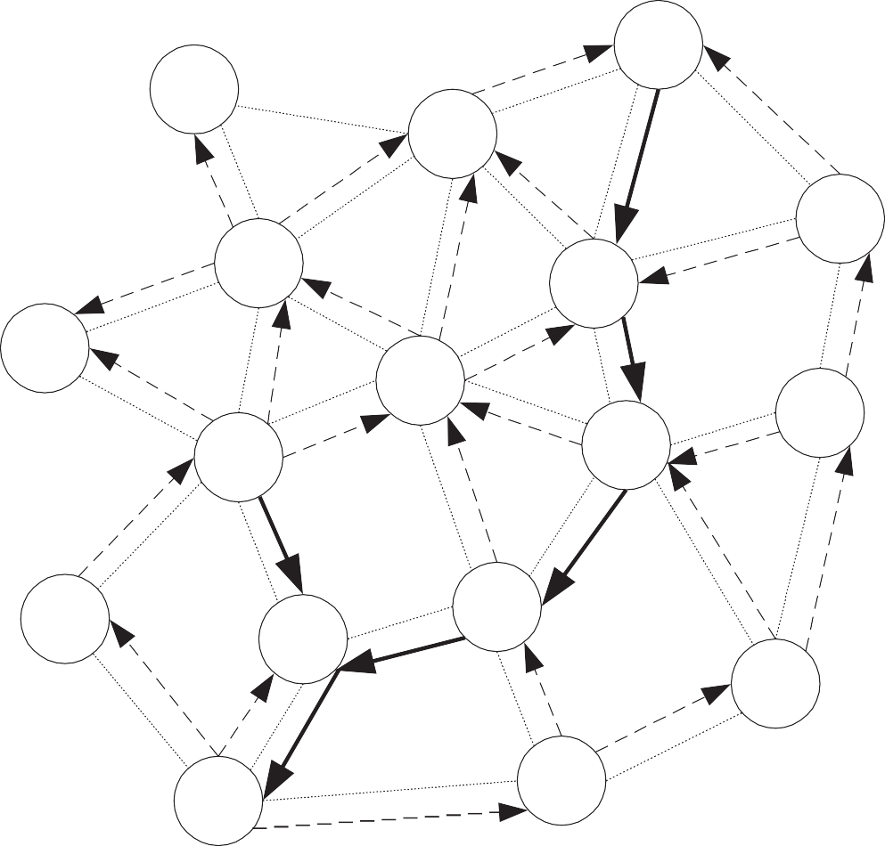  RouteRequest:  - DestSeqNum:5,  - SrcSeqNum: 2  Node 8:  - DestSeqNum 3;  Node 9:  - DestSeqNum 7; | 10 | 2 | 5 | 2 | 2.1.2
 | (OR)
14.b | Brief explain about Routing and Traffic Engineering with MPLS  Multi Protocol Label Switching (MPLS) is an IP packet routing technique that routes IP packet through paths via labels instead of looking at complex routing tables of routers. This feature helps in increasing the delivery rate of IP packets.  MPLS uses layer 3 service i.e, Internet Protocol, and uses router as forwarding device. The traffic of different customers is separated from each other because MPLS works somewhat like VPN. It does not work like regular VPN that encrypts the data but it ensures packet from one customer cannot be received by another customer. An MPLS header is added to packet that lies between layers 2 and 3. Hence, it is also considers to be Layer 2.5 protocol.  MPLS Header –  The MPLS Header is 32 bit long and is divided into four parts –  - Label – This field is 20 bit long and can take value b/w 0 & 2²⁰ – 1.  - Exp – They are 3 bits long and used for Quality of Service(QoS).  - Bottom of stack (S) – It is of size 1 bit. MPLS labels are stacked one over other. If there is only one label remained in MPLS header, then its value is 1 otherwise 0.  - Time to Live (TTL) – It is 8 bit long and its value is decreased by one at each hop to prevent packet to get stuck in network. | 10 | 2 | 5 | 2 | 2.1.2

Course Outcome (CO) and Bloom’s level (BL) Coverage in Questions
